M

IT Corporations

**1800 Bronson Boulevard**

**Fennimore, WI 53809-9778**

**800.362.3322**

**ibm@communications.net**

[**http://www.ibm.com**](http://www.ibm.com)

**Date:** December 16, 2010

**To:** Paul Murphey, SWTC Communication Instructor

**From:** Sam Schuetz, Written Communication Student ss

Mike Wall, Written Communication Student mw

Shayla Moyer, Written Communication Student sm

**Subject:** ***Informative Report Describing Important IT Careers and Qualifications***

**Introduction**

*Background*

In the field of information technology (IT), computer programmers work with computer programs and consult users to identify problems. They develop and evaluate the users’ needs. Programmers should have knowledge of coding and debugging. They need to discover problems and how to fix them. They connect data from project specifications, along with statements of problems and procedures, to create or modify computer programs. Computer programmers need to know how to plan, develop, test, and document computer programs by applying knowledge of logical operations. Salaries start at $32,000 (***see Figure 1***) and go up from there, depending on the experience and education of the programmer.

**Figure 1. Pay Scale (source: Stephenson, C., 2006)**

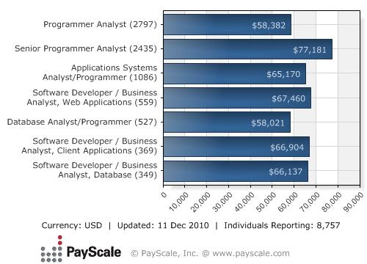

*Purpose Statement*

This report presents data regarding important IT corporations. This report will inform programmers as to the history of two important corporations and the qualifications that are required of programmers.

*Scope*

This report will include the following: (1) history of IBM and Apple, (2) products and services, (3) size of workforce, (4) company earnings, (5) qualifications required, and conclusion.

**Discussion**



History of IBM

International Business Machines Corporation (IBM) started in 1924. The practices of the company are grounded in core values of a forward-thinking culture and management practices. They opened up new facilities from1938–1951 in Poughkeepsie, New York; Washington, D.C.; and San Jose, California. IBM promotes diversity and corporate philanthropy in its policies, focusing on opportunities for women, minorities, and the disabled. Their adoption of a host of progressive new employee and social programs made them well-known as one of the world’s most admired companies. IBM continued to expand and became the most profitable, admired, and iconic corporation in the IT industry. Their growth in the business helped them embrace the open standards for computing. Their culture was reshaped to refocus their attention on clients and become more responsible, agile, and collaborative. IBM was a pioneer in helping clients in a way that capitalized on the development of the new possibilities of global networks and business or what is known as the birth of e-business. IBM still continues to stand at the forefront of global technology and business. Source retrieved from IBM Archives: Interactive History

Products and Services

IBM provides many products and services that range from everyday services, servers, and system software to internet security.

Products of IBM include the following:

* AMD-processor-based servers
* Intel-processor-based servers
* Linux servers
* Mainframe servers
* Power systems
* Unix Servers
* Software as disk systems
* Hard drives/microdrives
* Network-attached storage
* Storage-area networks
* Storage software
* System software
* OEM systems
* Internet security
* Semiconductors
* Upgrades, accessories, and parts.

Services of IBM include the following:

* End-user services
* Intergraded communication services
* IT-strategy and architecture services
* Security services

Size of Workforce

***Figure 2*** shows a comparison of IBM’s workforce with that of other popular corporations. IBM is the leading corporation and is followed by HP and Microsoft.

**Figure 2. IBM Workforce Comparison**

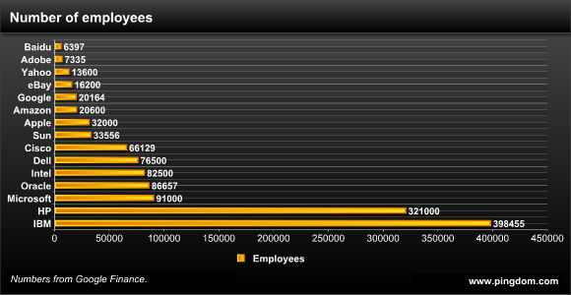

Source (Pingdom, 2008)

Salaries

Average salaries for IBM employees can range greatly and are based on the responsibilities of the position. Computer programmers can expect anywhere between $60,000 to $80,000. Refer to Figure 1 on the first page for career options and salary comparisons.

History of Apple

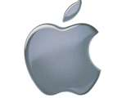

Apple Computer Incorporated was founded on January 3, 1977 in Cupertino, California. For more than two decades, Apple Inc. was the dominant manufacturer of personal computers. The company fell on hard times during the 1990s. In 1996 a new CEO brought a new corporate philosophy of recognizable products and simpler designs. With the successful introduction of the iPod in 2001and the incorporation of the iTunes store in 2003 Apple re-established itself as a world leader in the electronics industry. Today Apple is one of the largest technology firms in the world. Source from Wikipedia (December 13, 2010)

Products and Services

As Apple competes with many other corporations, it continues to provide excellent products and services for everyone.

***Figure 3*** lists the most popular Apple products and their current stock price.

**Figure 3. Popular Apple Products**

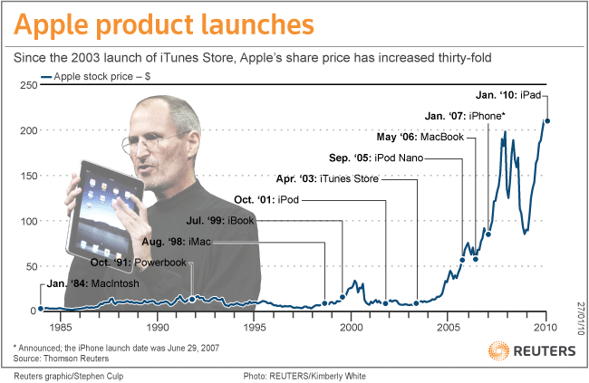

Apple services include the following:

* Apple Photo Services
* ITunes Store
* MobileMe

A self-service option is also offered for Apple customers who are interested in checking their coverage and repair status and who want to register for a new AppleCare Agreement.

Size of Work

Apple Inc. is a major manufacturer of computers and office equipment. The most recent figures available list over 49,400 employees from all around the world.

Earnings

A computer programmer at Apple Inc. averages about $91,000 per year.

Qualifications Required

A bachelor’s degree in Computer Science is required of most programmer companies. Programmers can also qualify with an associate’s degree. Other qualifications can include the following:

* Certification in a specific programming language or languages
* Familiarity with database systems
* Good communication skills
* An eye for detail
* An ability to think “out of the box”
* An analytical mind and problem solving skills

**Conclusions**

Based on the provided information, we draw the following conclusions:

* Programmers must have knowledge of coding and debugging.
* Becoming a programmer requires a college education.
* Salaries differ depending on the career chosen.
* IBM and Apple have a strong workforce.
* Many services and products are provided.

**References**

*Wikipedia.* (December 13, 2010) Apple Inc. Retrieved December 7, 2010 from http://en.wikipedia.org/wiki/Apple_inc.

Grothaus, M. (2010, April 15). *Apple #56 in fortune 500 rankings*. Retrieved December 7, 2010 from http://www.tuaw.com/2010/04/15/apple-56-in-fortune-500-rankings.

IBM Archives: Interactive History. Retrieved December 7, 2010from http://www-03.ibm.com/ibm/history/interactive/index.html.

IBM Services. Retrieved December 7, 2010 from http://www.ibm.com/technologyservices/us/en/.

Pingdom (2010) The size of IBM makes Microsoft and Google look like startups. (2009, May 4). Retrieved December 11, 2010 from http://royal.pingdom.com/2009/05/04/ibms-size-makes-microsoft-and-google-look-like-tiny-startups/.

Computer Programming Jobs. Retrieved December 13, 2010 from http://www.unixl.com/dir/information_technology/programming/computer_programming_jobs/.

Stephenson, C. (2006, October 27). A Rant About Salaries. Retrieved December 7, 2010 from http://blog.acm.org/archives/csta/news_and_views/.